**CSCI 3308**

**Phu Nguyen, Duy Tran,**

**Katherine Pham, Ryan Sheng**

**Project Proposal**

**Proposal: MENU429**  
  
**Description.**  
The web app we are developing is a recipes networking/sharing site. This application will allow the user to submit their own recipes for personal reference and share with other people. Like the format of a regular, traditional recipe, the user will be able to create a recipe title, recipe description, list of ingredients and measurements needed and the steps to create their masterpieces. Once the recipe is created, the application will store it onto the server/database for future retrieval.  
  
**Technologies/Tools of the Trade**  
The recipes will be stored in a MySQL database, whereas the rest of the site (content, layout, etc.) will be focused on PHP, HTML5, and CSS (possibly for a mobile version). We will also use Github as our repository, SimpleTest for unit testing, and Apache server.  
  
**Interface.**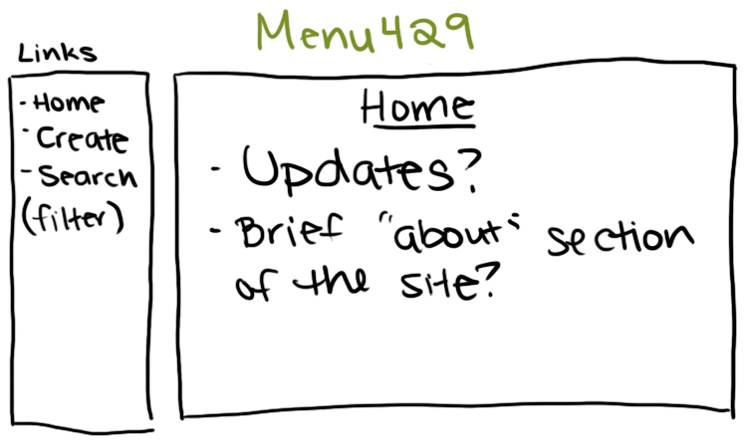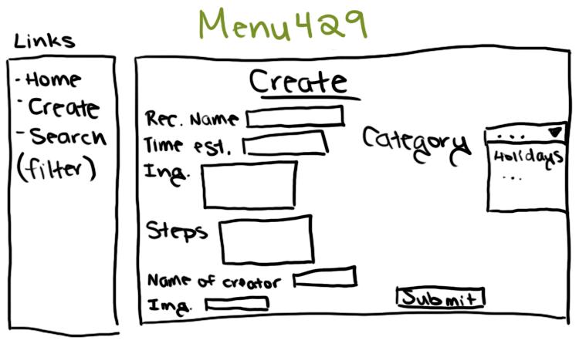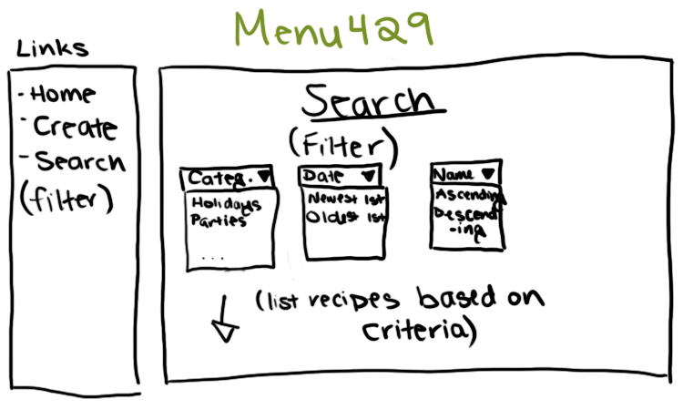  
  
**Project Plan.**  
Iteration One

|  |  |  |
| --- | --- | --- |
| Task | Priority | Estimate Time |
| 1. Register Github (repository) account | 10 | 15 minutes |
| 2. Set up a working environment for everyone (install xampp) | 10 | 10 minutes |
| 3. Design User Interface | 10 | 3 days |
| 4. Create a database with appropriate fields | 10 | 1 hour |
| 5. Become acquainted with PHP | 10 | 3 days |
| 6. Learn and attempt simple unit tests for PHP | 10 | 3 days |

Summary: The basic design of the app will formed.  
Total Days: About 10 days  
  
Iteration Two

|  |  |  |
| --- | --- | --- |
| Task | Priority | Estimate Time |
| 7. Implement the design the main homepage | 20 | 3 days |
| 8. Implement the submit feature | 20 | 2 days |
| 9. Unit tests for Iteration 2 | 20 | 2 days |

Summary: Get the user interface up and running. The users can be able to create recipes and store it into the database.  
Total Days: About 7 days  
  
Iteration Three/Final Iteration

|  |  |  |
| --- | --- | --- |
| Task | Priority | Estimate Time |
| 10. Implement the displaying/retrieval of recipes | 30 | 3 days |
| 11. Implement the sorting feature by specified field | 30 | 4 days |
| 12. Unit test on iteration 3 features | 30 | 5 days |

Summary: User can filter recipes by category of food/date of creation (default)/recipe name/time estimation. (Food categories: African, Asian, American, European, Latin American; subcategories of entrees, side dishes, desserts, beverages/drinks)  
Total Days: About 12 days  
  
Summary of All Three Iterations: At the end of iteration 3, we expect to have a web-app that allows users to post their recipes and redisplay them back on the homepage. The viewer can also choose to filter the results according to their preferences.  
  
Time Allowance:    
- Implement the functionality of creating a unique URL for each recipe.  
- Allow user to upload an image of their recipe.  
  
**Group Schedule:**  
We’re meeting twice a week on Tuesday and Thursday for 30-minute Scrum meetings and code development on every Saturdays for one hour. During these meetings, we will conduct reviews, progress for each members on the project and group coding sessions.